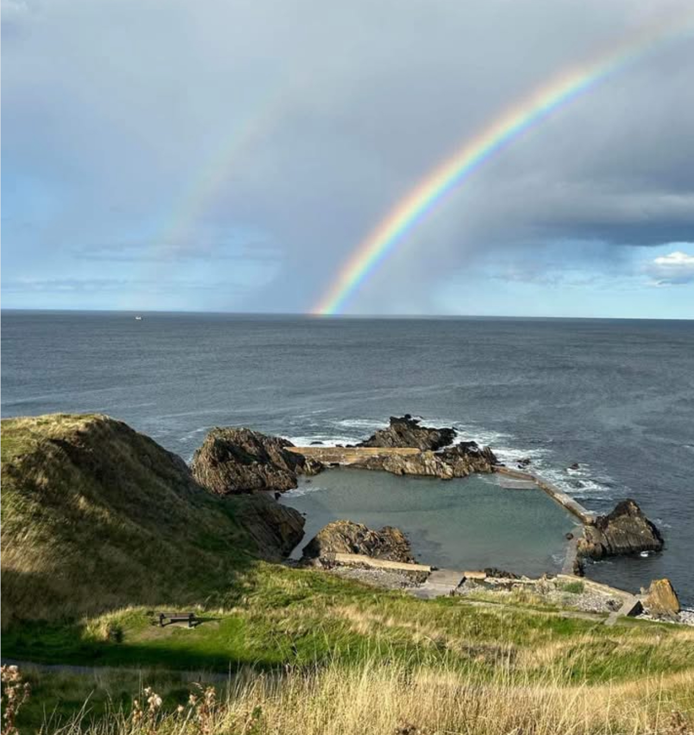

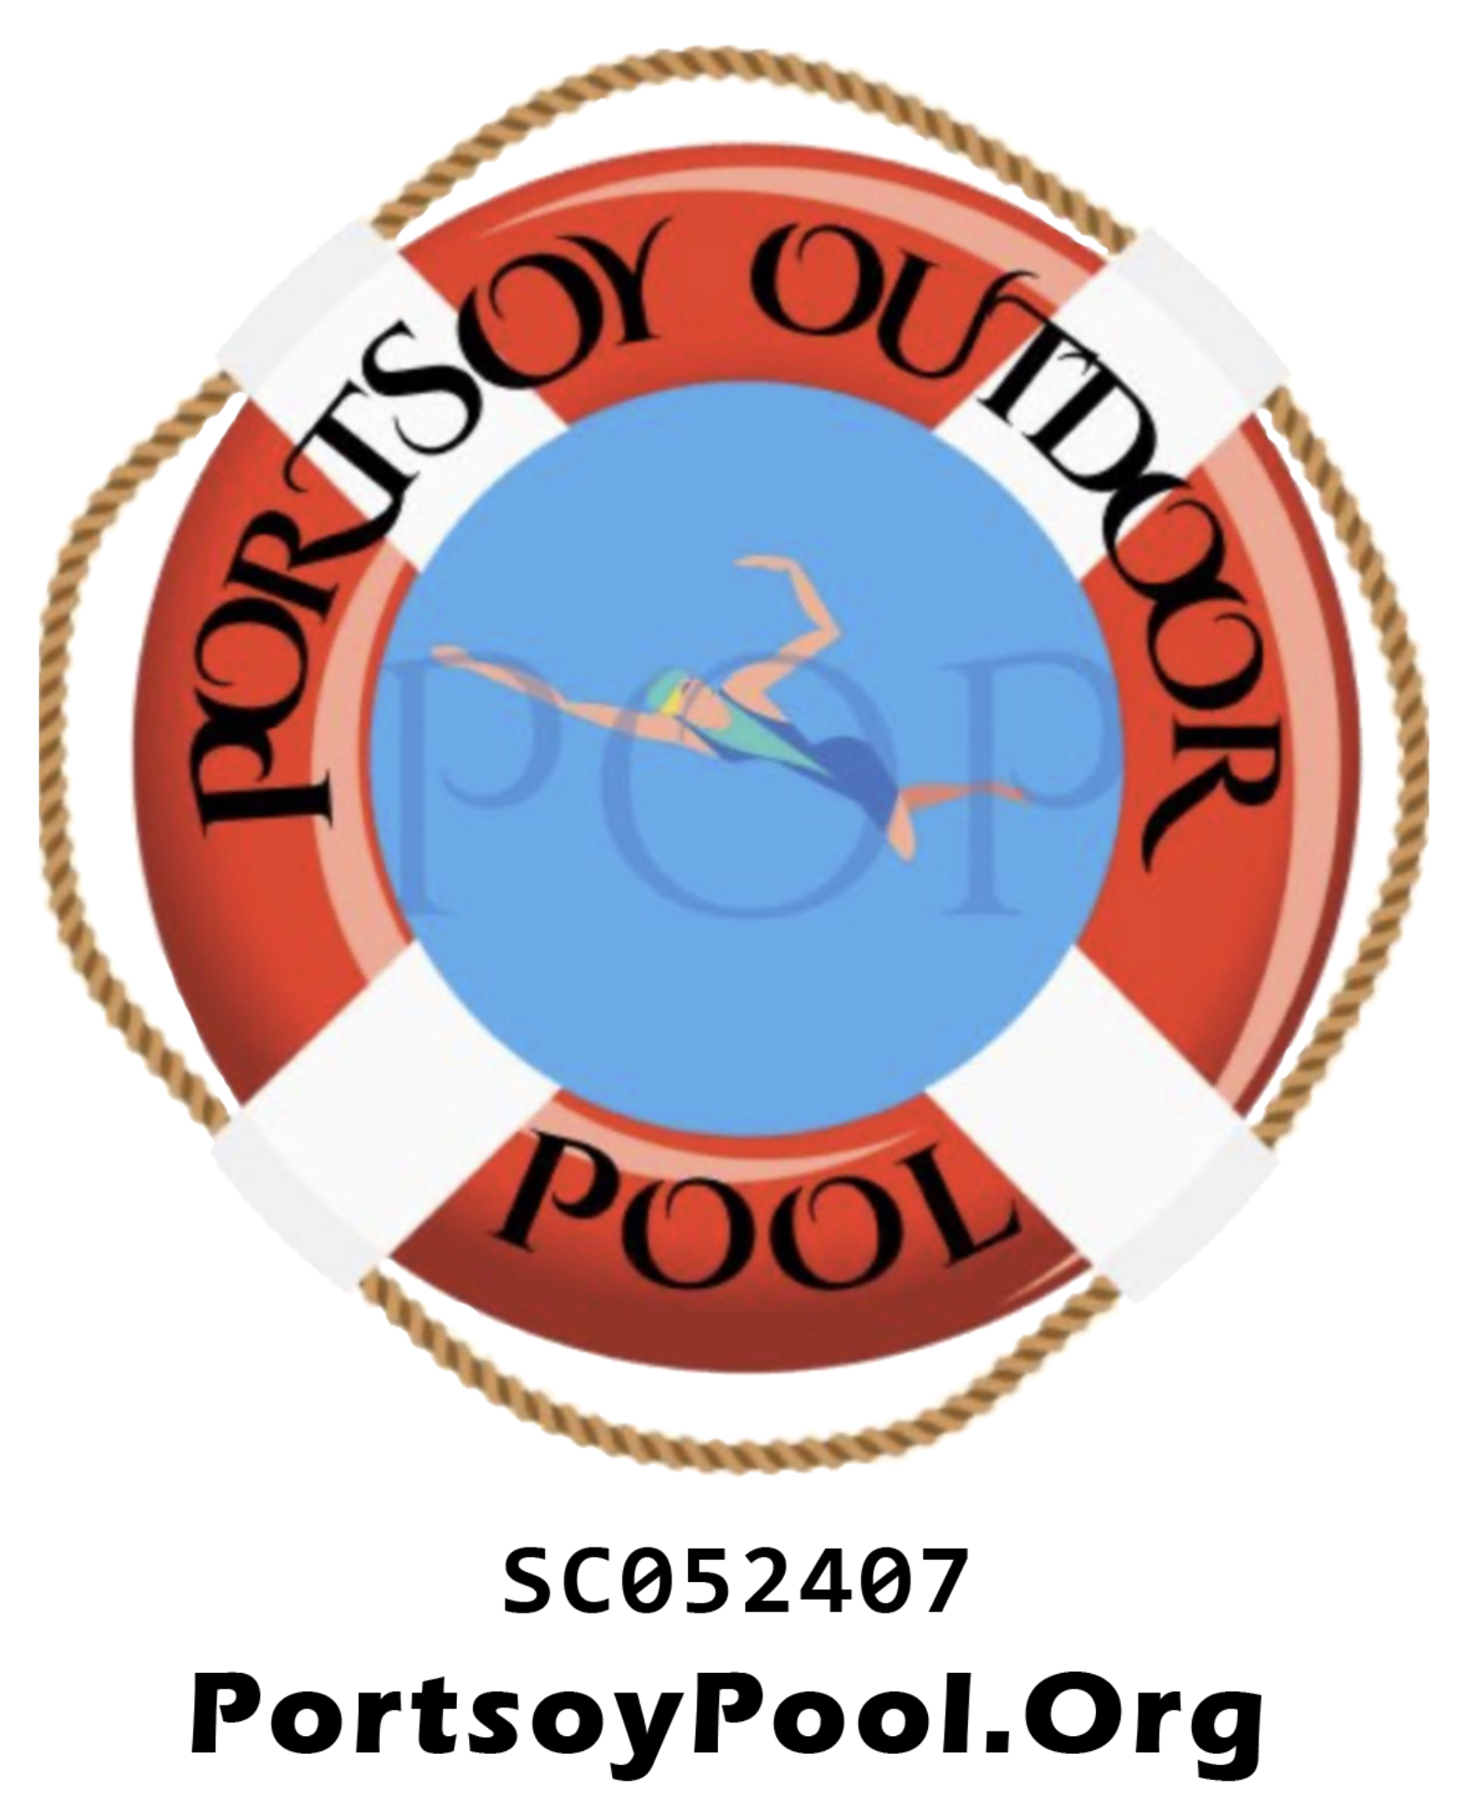

annual update 2025

Portsoy outdoor pool
Scottish Registered Charity SCO52407

UPDATE

MEMBERSHIP AND TRUSTEES RECRUITMENT
Our followers on Facebook and within the community will have seen our recruitment drive over the summer. Feedback from potential funders has been that we need to show more engagement with and from the community, so we have reached out to build member numbers and enhance the Board with additional Trustees. We are delighted to report that we now have 9 Trustees, who were confirmed in their posts at the recent Annual General Meeting. We are always keen to have new members join us, so if you’re interested do drop an email to chairman@portsoypool.org or message us on Facebook.

FUNDING OPPORTUNITIES
Like many charities and organisations, the opportunity to secure funding has become increasingly difficult. What used to be straightforward and readily accessible has become much more difficult, with funding streams constantly reporting that they are significantly oversubscribed. Funding organisations are reducing the amount of money given to charities and are being very selective as to what they will fund.

Over the last year we have been working hard to try and find suitable funding for a Feasibility Study which is a requirement for the Community Asset Transfer (CAT).

Our Community Asset Transfer Application will not be accepted if we do not have the study completed by a qualified company, but most funding providers are no longer providing funding for surveys of any sort, so the likelihood of securing the money we need for our Feasibility Study is extremely slim.

We had to look at what can be done to give us a better chance of securing funding for the whole project so we have had to make some significant changes which hopefully will be looked upon in a more favourable manner.

Buildings/FACILITIES
As there had been a building on site many years ago, part of the CAT requirements is that we replace this. We were fortunate enough to have had a Trustee (Colin Clark) who had a friend who owned an architect practice and kindly designed some wonderful, aspirational building plans for us free of charge. This was a huge bonus and saved the charity many thousands of pounds on architectural and planning fees.

Many of you may have seen the plans for the the proposed buildings and we’re sure you’d agree that they are very impressive, however being an impressive building had its downsides and one of them is cost. We estimated that the project could have cost as much as £1 million pounds!

Most funders look for the projects they fund to provide “match funding” which meant that we could have had to find funders to make up the £500k, along with a larger funder for the balance.
In today’s climate, we feel that this is an impossible task, so we had to take the decision to look at other less ambitious options that are more achievable and available for our charity.

We thank Colin Clark and the Architect for the hard work, time and money invested to produce the stunning drawings and hopefully one day may be able to make use of the plans.

MOVING FORWARD
Over the last year or so we have been looking at other similar projects in and around Aberdeenshire and Moray and what has worked for them. Time and again this has come back to the use of portable, modular buildings. Places like Greyhope Bay at the Torry Battery in Aberdeen, Callerdyke Outdoor Pool, Cruden Bay just to name a few have found that converted shipping containers are not only versatile, but the cost saving is immense.

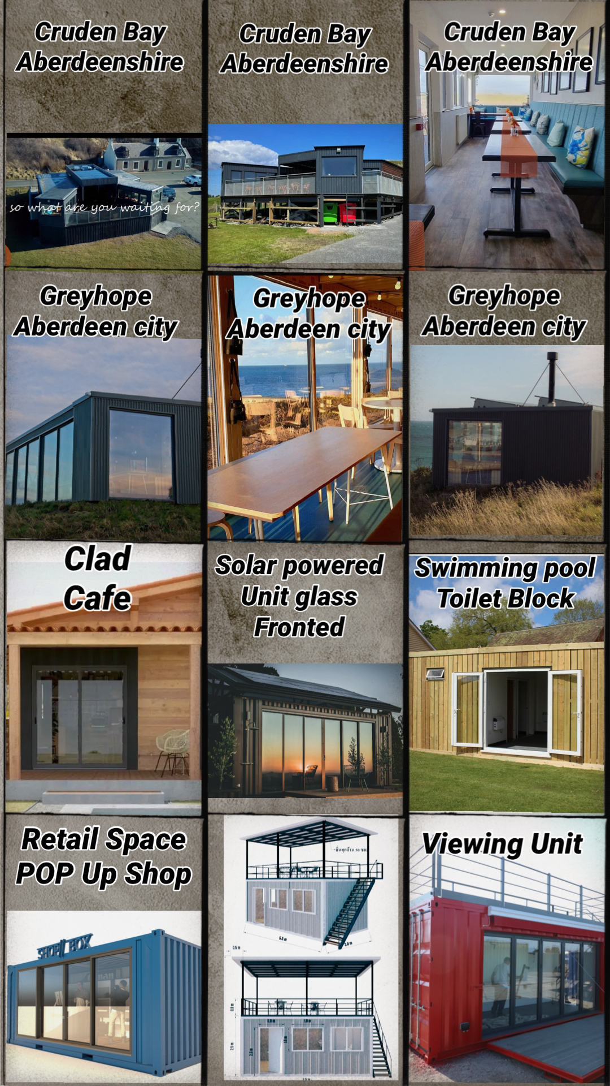

Over the last month or so we looked at how much such units would cost and how readily available they are. A local company in Huntly had a few containers that were ideal for our project which we viewed. We were extremely impressed by the quality and set up of the containers.

After a Emergency Meeting of the Trustees we made the decision to purchase 2 containers that sit back-to-back. Both are 24ft x 10ft. One of the units is a fully fitted out toilet block with a shower, the other has a small kitchen area with large office space which can be redesigned to suit our needs. Both units are site ready and we still intend to continue with the plans to be off grid and fully accessible.

Whilst this was a leap of faith, it is obviously a lot less ambitious financially and can be added to, upgrading as the charity grows.
The good news is the cost to the charity can be covered within our current banked finances.

Some of you may remember in 2024 local business owner and professional cyclist, Jodie Smith, completed an exhaustive cycle run of 500km in less than a day and raised over a staggering £7000, for which we are incredibly grateful. After speaking to Jodie, he agreed with our proposal to use the money he raised to buy the containers. This was agreed by the Trustees and the order has been placed.

The containers are now a Charity Asset and we no longer have the hugely challenging target of raising funds for a costly building, so can concentrate on upgrading the pool itself. allowing funding groups to look at us in a more favourable way.

So, thanks to Jodie Smith’s generosity the Charity has buildings/facilities ready to site when we complete the Community Asset Transfer.

This leaves money to complete the essential Feasibility Study so we must thank everyone that has donated to the Charity whether it’s money, goods, raffle prizes or time we are extremely grateful.

Obviously, the containers need to be stored until such time as we can put them on site. To save the charity storage charges, Seafield Estate, who have been supportive of the project from the start, have offered us a lease for the top car park on Pool Road.

The lease agreed is for the whole car park which will continue to be used by coastal walkers, but we will no longer allow camper vans and travellers to use the site unless prior permission is obtained from the Charity due to our insurance policy restrictions.

Here are some images of the containers. Like many groups and organisations these containers can be updated with cladding either wood or another sustainable material. You can see from one of the pictures in the newsletter these containers can be transformed for very little cost.

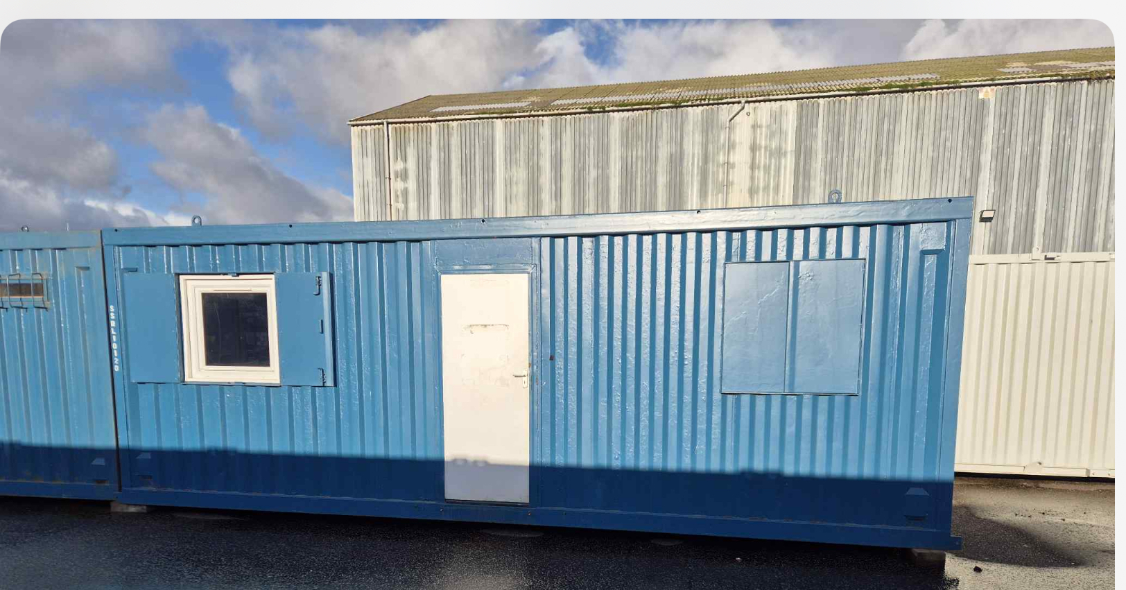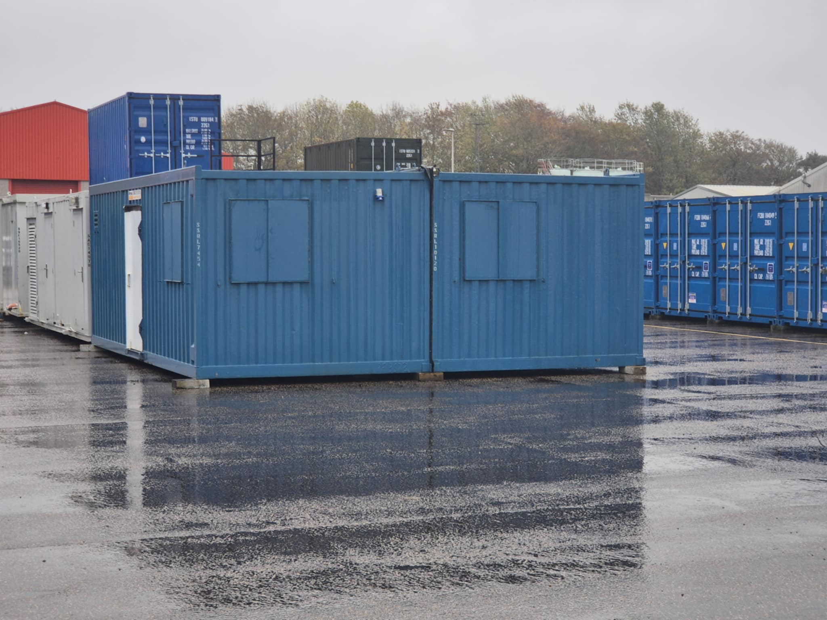
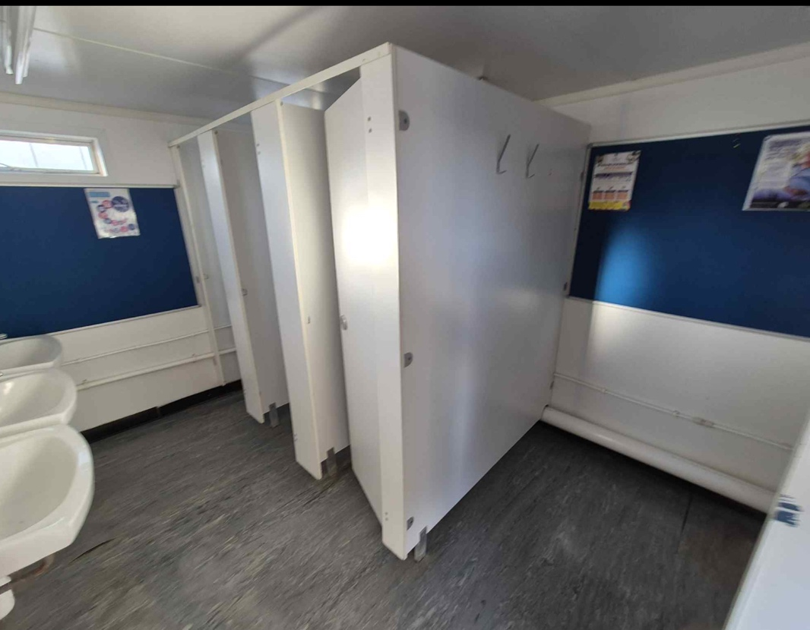

Preferred option for accessible toilet and shower:

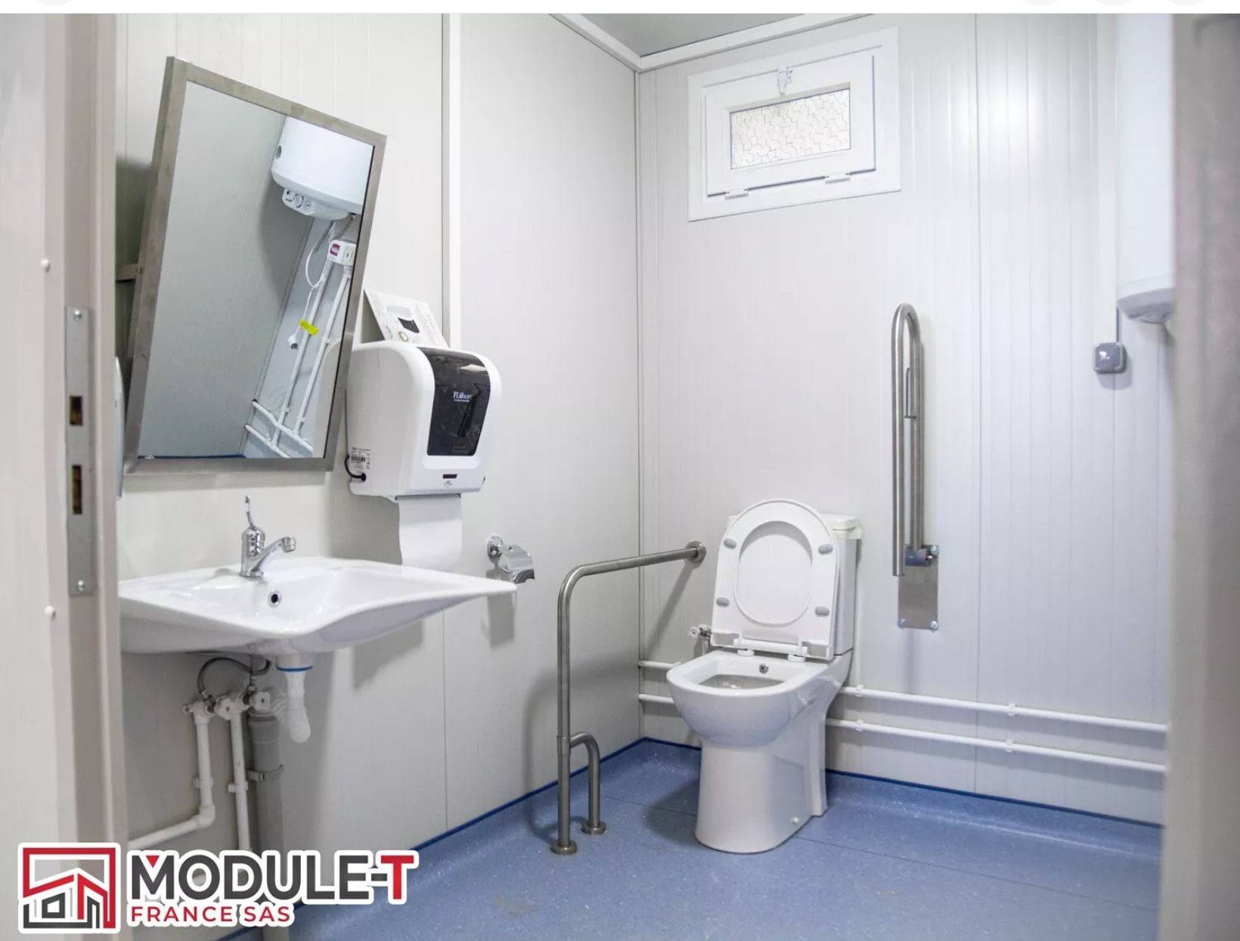

WHAT ARE THE PLANS FOR 2026?

Our priorities for the coming year are:

Finalize lease.
Organize delivery of containers to location, secure and safely stored until CAT is completed and they can be re-located to final location, once CAT and planning approval in place.
Progress with Feasibility Study process.
Continue the conversation with the energy provider about off-grid energy.
Focus on funding applications for fully accessible toilet and shower unit.
Continue our discussions with the Baxter Foundation about a viewing platform building, with educational possibilities.
Finalize our Business Plan.
Submit our Community Asset Transfer Proposal.
Continue fundraising and networking.
Carry out more community engagement, getting more volunteers and members, using community voices to help guide and influence the project, especially now it is more financially achievable.

A huge thank you to everyone who has been involved with Portsoy Outdoor Pool.
Your contribution, no matter how small or large, is crucially important to moving things towards our vision of bringing the pool back into community ownership and use, for the benefit of local residents, businesses and visitors alike.

Together we can make this happen!

With special thanks to our main funder Jodie Smith at:


